JUDAICA | 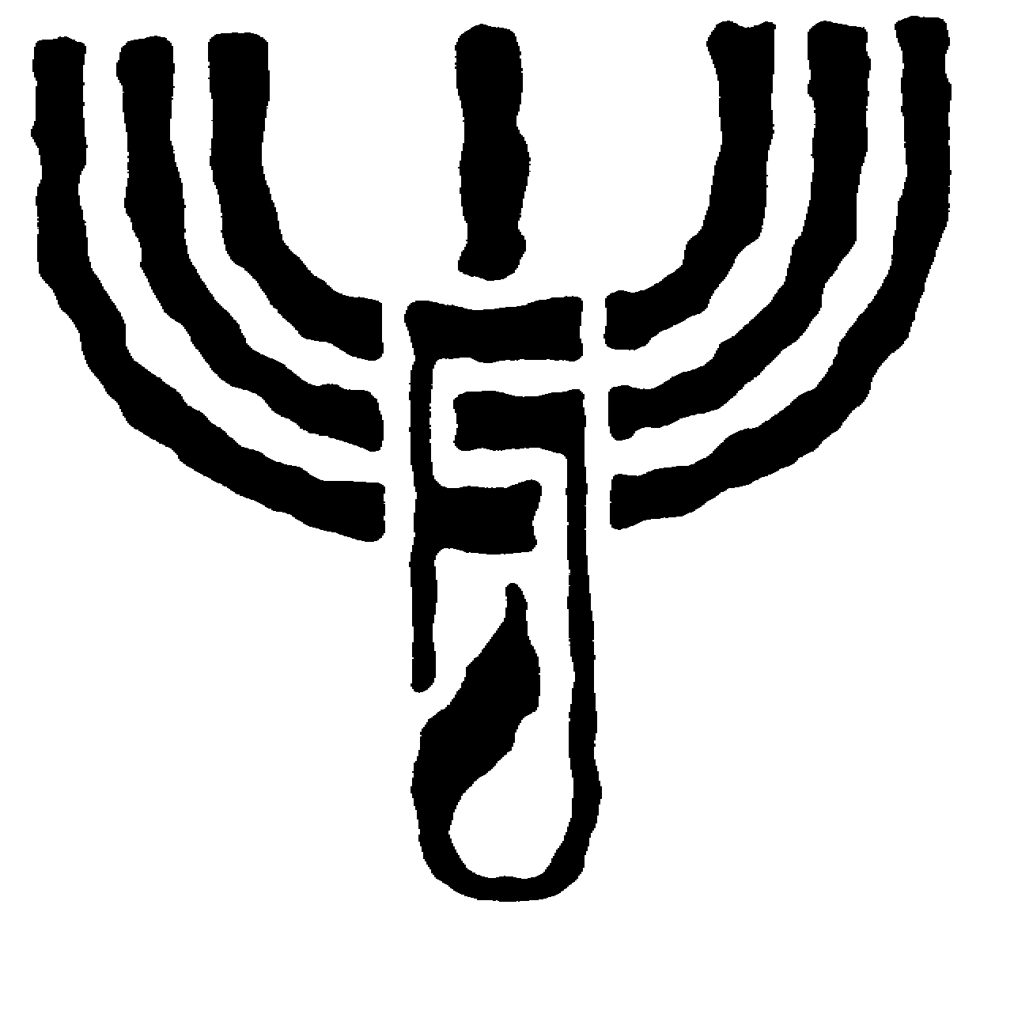 | FOUNDATION
CENTER FOR JEWISH CULTURE
P R O G R A M – M A R C H 2 0 0 2

Friday, March 1st, at 7.00 p.m.
GUITAR CONCERTS AT THE CENTER
Guitar concert performed by Michal PINDAKIEWICZ (Warsaw).

Saturday, March 2nd, at 6.00 p.m.
Guitar concert performed by Mauricio DIAZ (Mexico) organized jointly with the Cervantes Institute in Warsaw.

Sunday, March 3rd, at 6.00 Pp.m.
Concert performed by the HARMONICA TRIO (Myslowice): Zygmunt ZGRAJA, Zdzisław KUNINIEC and Janusz ZAJAC.

Monday, March 4th, at 6.00 p.m.
POLES AND JEWS – ONCE AGAIN?
Meeting with Prof. Jerzy JEDLICKI and Sergiusz KOWALSKI moderated by Prof. Jan WOLENSKI.

Tuesday, March 5th, at 6.00 p.m.
Film showing: Messenger of Hope by Dušan HUDEC (Slovakia).

Wednesday, March 6th, at 6.00 p.m.
POLAND’S INTEGRATION
WITH THE EUROPEAN UNION
Polish Agriculture - meeting with Dr. Maria STOLZMAN.

Thursday, March 7th, at 6.00 p.m.
DEMOCRACY AND TOLERANCE
Poland Before a Great Change – meeting with Prof. Lena KOLARSKA-BOBINSKA of the Institute of Public Affairs in Warsaw.

Saturday, March 9th, at 11.00.a.m.
Book auction organized by the Antiquarian Bookstore RARA AVIS in Cracow.

Sunday, March 10th, at 6.00 p.m.
Chopin and His Pupils – piano recital by Voytek MATUSHEVSKY (USA).

Monday, March 11th, at 6.00 p.m.
ANNIVERSARY OF MARCH ’68 EVENTS IN POLAND
Politics in March, March in the “Polityka” weekly – meeting with Mieczyslaw F. RAKOWSKI, former Editor-in-Chief of the “Polityka” weekly.

Tuesday, March 12th, at 6.00 p.m.
Film showing: Train to Vienna by Marek DRAZEWSKI (in Polish, 26 min.) and Remembrance of the Years Past by Jan SOSINSKI (English subtitles, 57 min.) followed by meeting with Michal SOBELMAN, author of the script.

Wednesday, March 13th, at 6.00 p.m.
Opening of the paintings exhibition by Beata ZALOT (Nowy Targ).

Thursday, March 14th, at 6.00 p.m.
Book presentation: Christianity and Europe. Studies on the History of the Western Civilization by Prof. Andrzej FLIS (Jagiellonian University).

Friday, March 15th, at 7.00 p.m.
Jazz concert performed by Jorgos SKOLIAS (vocal) and Bronislaw DUZY (trombone).

Sunday, March 17th, 2002
MARCH OF MEMORY
commemorating the 59th anniversary
of the Cracow’s ghetto liquidation
11.00 a.m. – meeting with Stella MÜLLER-MADEJ, Cracow ghetto survivor
12.00 noon – beginning of the MARCH OF MEMORY from the former Cracow ghetto Umschlagplatz to the former KL Plaszow, with participation of ghetto and camp survivors

KALEIDOSCOPE OF CULTURES: UKRAINIANS IN POLAND

Sunday, March 17th, at 6.00 p.m.
Concert of the Ukrainian folk music performed by the DREWO ensemble for Kiev.

Monday, March 18th, at 6.00 p.m.
Neighbors of the Eastern Tradition – Ukrainians – meeting with Father Marek SKORKA of the Greek – Orthodox Church in Warsaw.

Tuesday, March 19th, at 6.00 p.m.
Ukrainians in Poland after WWII – in Search of the Identity – meeting with Piotr TYMA, Secretary of the Ukrainian Society in Poland.

Wednesday, March 20th, at 6.00 p.m.
Concert of the Ukrainian music performed by the BANDURA ensemble from Przemysl.

Thursday, March 21st, at 6.00 p.m.
Poland and Ukraine – Achievements, Challenges and Threats – meeting with Prof. Bohdan OSADCZUK, eminent Ukrainian historian living in Berlin.

Friday, March 22nd, at 6.00 p.m.
Film showing: Myloserdia dweri by K. Krzyzanowski, Controversy About the Temple by W. Szumowski and W. Janda, And Forgive us Our Debts by W. Janda, and Jaworzno Camp by A. Warchil

Saturday, March 23rd, 6.00 p.m.
Poetry by Taras Szewczenko, Ukrainian poet, presented by a group of students and Julia DOSZNA, Ukrainian singer. An event organized by the Cracow’s Branch of the Ukrainian Society in Poland.

***

Monday, March 25th, at 6.00 p.m.
MARCH 27th – INTERNATIONAL DAY OF THEATRE
Film showing: Jakub Rotbaum by Artur Hofman and Michal Szwejlich – an Actor by Krystyna Bevis-Shmeruk.

CENTER FOR JEWISH CULTURE, MEISELSA STREET 17, 31-058 CRACOW, POLAND,
TEL. ++48 12 / 430 64 49, 430 64 52, FAX ++48 12 / 430 64 97

